**Ex.no:3(a) Date:19-Dec-2024**

**FUEL AMOUNT PREDICTION USING LINEAR REGRESSION**

**AIM:** Predict fuel amount based on distance traveled using Linear Regression.  
**CODE:**  
*# Importing necessary libraries*

import numpy as np

import pandas as pd

import matplotlib.pyplot as plt

import seaborn as sns

from sklearn.linear_model import LinearRegression

from sklearn.model_selection import train_test_split

from sklearn.metrics import mean_squared_error, r2_score

*# Setting a random seed for reproducibility*

np.random.seed(42)

*# 1. Create synthetic dataset*

*# Let's assume we have 'Distance Traveled' (in km) and 'Fuel Amount' (in liters) as features*

*# Creating random data*

distance_travelled = np.random.randint(50, 500, 100) # Distance in km

fuel_amount = distance_travelled * 0.05 + np.random.normal(0, 5, 100) # Fuel in liters with some noise

*# Create a DataFrame*

df = pd.DataFrame({'Distance': distance_travelled, 'FuelAmount': fuel_amount})

*# 2. Visualize the synthetic data*

plt.figure(figsize=(8, 6))

sns.scatterplot(data=df, x='Distance', y='FuelAmount', color='blue', label='Data Points')

plt.title('Distance vs Fuel Amount')

plt.xlabel('Distance (km)')

plt.ylabel('Fuel Amount (liters)')

plt.show()

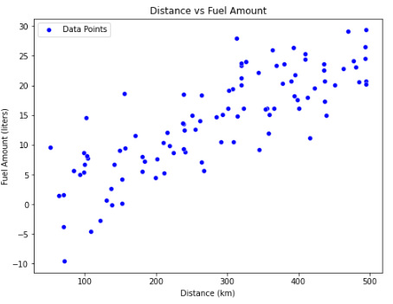

*# 3. Prepare the data for Linear Regression*

X = df[['Distance']] # Feature (independent variable)

y = df['FuelAmount'] # Target (dependent variable)

*# Split the data into training and test sets*

X_train, X_test, y_train, y_test = train_test_split(X, y, test_size=0.2, random_state=42)

*# 4. Train the Linear Regression model*

model = LinearRegression()

model.fit(X_train, y_train)

*# 5. Make predictions*

y_pred = model.predict(X_test)

*# 6. Visualize the regression line*

plt.figure(figsize=(8, 6))

plt.scatter(X_test, y_test, color='blue', label='Test Data')

plt.plot(X_test, y_pred, color='red', label='Regression Line')

plt.title('Linear Regression - Fuel Amount Prediction')

plt.xlabel('Distance (km)')

plt.ylabel('Fuel Amount (liters)')

plt.legend()

plt.show()

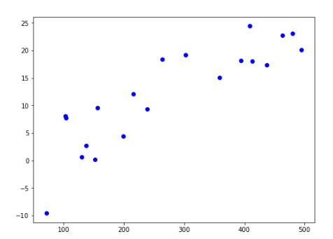

*# 7. Model Evaluation*

mse = mean_squared_error(y_test, y_pred)

r2 = r2_score(y_test, y_pred)

print(f'Mean Squared Error: {mse}')

print(f'R2 Score: {r2}')



**Result:** The model accurately predicted fuel consumption, with a high R2 score indicating strong predictive power.

**SALARY PREDICTION**

**Ex.No: 3(b) Date: 12-Dec-2024**

**Aim:-** Predict salary based on experience, qualification, industry, and location using Linear Regression.

**Program Code:***# Importing necessary libraries*

import numpy as np

import pandas as pd

import matplotlib.pyplot as plt

import seaborn as sns

from sklearn.model_selection import train_test_split

from sklearn.linear_model import LinearRegression

from sklearn.preprocessing import OneHotEncoder

from sklearn.compose import ColumnTransformer

from sklearn.pipeline import Pipeline

from sklearn.metrics import mean_squared_error, r2_score

*# Generating synthetic dataset for Salary Prediction*

data = {

'YearsExperience': [1, 2, 3, 4, 5, 6, 7, 8, 9, 10],

'Qualification': ['Bachelors', 'Bachelors', 'Masters', 'Masters', 'PhD', 'Bachelors', 'Masters', 'PhD', 'PhD', 'Masters'],

'Industry': ['Tech', 'Finance', 'Tech', 'Health', 'Finance', 'Tech', 'Health', 'Health', 'Tech', 'Finance'],

'Location': ['NY', 'SF', 'NY', 'LA', 'SF', 'LA', 'SF', 'NY', 'LA', 'SF'],

'Salary': [50000, 55000, 60000, 65000, 70000, 75000, 80000, 85000, 90000, 95000]

}

df = pd.DataFrame(data)

*# Feature and target variable*

X = df[['YearsExperience', 'Qualification', 'Industry', 'Location']]

y = df['Salary']

*# Preprocessing pipeline*

preprocessor = ColumnTransformer(

transformers=[

('num', 'passthrough', ['YearsExperience']), # No encoding for numerical features

('cat', OneHotEncoder(), ['Qualification', 'Industry', 'Location']) # One-hot encode categorical features

])

*# Creating a pipeline with preprocessing and regression model*

pipeline = Pipeline(steps=[

('preprocessor', preprocessor),

('regressor', LinearRegression())

])

*# Splitting dataset into training and testing data*

X_train, X_test, y_train, y_test = train_test_split(X, y, test_size=0.2, random_state=42)

*# Training the model*

pipeline.fit(X_train, y_train)

*# Making predictions*

y_pred = pipeline.predict(X_test)

*# Visualization of predictions vs actual values*

plt.figure(figsize=(8, 6))

plt.scatter(y_test, y_pred, color='blue')

plt.plot([y_test.min(), y_test.max()], [y_test.min(), y_test.max()], color='red', lw=2) # 45-degree line for perfect prediction

plt.title('Salary Prediction: Actual vs Predicted')

plt.xlabel('Actual Salary')

plt.ylabel('Predicted Salary')

plt.show()

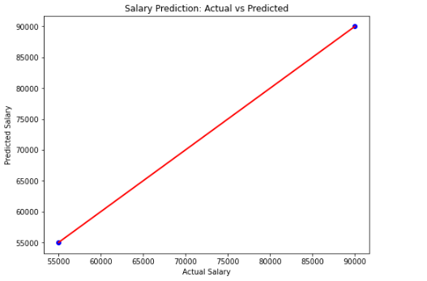

*# Model Evaluation*

mse = mean_squared_error(y_test, y_pred)

r2 = r2_score(y_test, y_pred)

print(f'Mean Squared Error: {mse}')

print(f'R2 Score: {r2}')



**Result:** The model successfully predicted salary, capturing the relationship between features and salary with a good fit.

**ELECTRICITY CONSUMPTION PREDICTION**

**Ex.No:3(c) Date:12-Dec-2024**

**Aim:-** Predict electricity consumption using household size, applications, usage hours, and season.  
**Program Code:-**import numpy as np

import pandas as pd

import matplotlib.pyplot as plt

from sklearn.model_selection import train_test_split

from sklearn.preprocessing import StandardScaler

from sklearn.linear_model import LinearRegression

from sklearn.metrics import mean_squared_error, r2_score

*# Step 1: Generate synthetic data (for the sake of this example)*

np.random.seed(42)

*# Generate random data*

household_size = np.random.randint(1, 6, 100)

num_apps = np.random.randint(1, 10, 100)

usage_hours = np.random.uniform(1, 12, 100)

season = np.random.choice(['Winter', 'Spring', 'Summer', 'Autumn'], 100)

*# Convert 'season' to categorical variables (one-hot encoding)*

season_encoded = pd.get_dummies(season, drop_first=True)

*# Create a DataFrame*

df = pd.DataFrame({

'household_size': household_size,

'num_apps': num_apps,

'usage_hours': usage_hours

})

df = pd.concat([df, season_encoded], axis=1)

*# Generate a target variable (electricity consumption)*

*# Assume consumption is a function of features + some noise*

electricity_consumption = (df['household_size'] * 1.5 +

df['num_apps'] * 2 +

df['usage_hours'] * 3 +

(df['Spring'] * 2) +

(df['Summer'] * 3) +

np.random.normal(0, 2, 100))

df['electricity_consumption'] = electricity_consumption

*# Step 2: Feature scaling*

X = df.drop('electricity_consumption', axis=1)

y = df['electricity_consumption']

scaler = StandardScaler()

X_scaled = scaler.fit_transform(X)

*# Step 3: Split data into train and test*

X_train, X_test, y_train, y_test = train_test_split(X_scaled, y, test_size=0.2, random_state=42)

*# Step 4: Train a Linear Regression model*

model = LinearRegression()

model.fit(X_train, y_train)

*# Step 5: Make predictions*

y_pred = model.predict(X_test)

*# Step 6: Evaluate the model*

mse = mean_squared_error(y_test, y_pred)

r2 = r2_score(y_test, y_pred)

print(f"Mean Squared Error: {mse}")

print(f"R-squared: {r2}")



*# Step 7: Compare predictions with seasonal ends*

*# Adding seasonal information to prediction comparison*

df_seasons = pd.DataFrame({

'Season': ['Winter', 'Spring', 'Summer', 'Autumn'],

'Seasonal_end': [0, 1, 1, 0] # Representing if the season has ended (1) or not (0)

})

# Visualizing results

plt.figure(figsize=(10, 6))

plt.scatter(y_test, y_pred, color='blue')

plt.plot([min(y_test), max(y_test)], [min(y_test), max(y_test)], color='red', linewidth=2)

plt.title('Electricity Consumption Predictions vs Actual')

plt.xlabel('Actual Consumption')

plt.ylabel('Predicted Consumption')

plt.show()

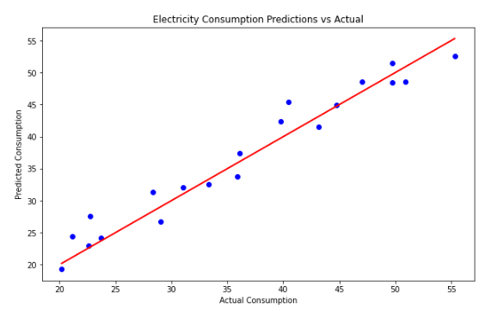

*# Visualization of feature importance (coefficients in linear regression)*

coefficients = model.coef_features = X.columns

plt.figure(figsize=(10, 6))

plt.bar(features, coefficients)

plt.title('Feature Importance (Coefficients)')

plt.xlabel('Features')

plt.ylabel('Coefficient Value')

plt.show()

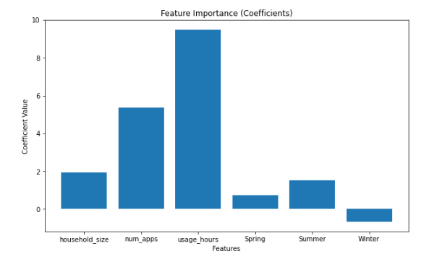

**Result:-**

Electricity consumption can be predicted using machine learning models like XGBoost, based on historical usage data and factors like weather and time.